AASHTO Innovation Initiative
[Proposed] Nomination of Innovation Ready for Implementation

Sponsor

Nominations must be submitted by an AASHTO member DOT willing to help promote the innovation. If selected, the sponsoring DOT will be asked to promote the innovation to other states by participating on a Lead States Team supported by the AASHTO Innovation Initiative.
1. Sponsoring DOT (State): Texas DOT
2. Name and Title: Stan Swiatek, District Engineer, Waco District
Organization: Texas Department of Transportation
Street Address: 100 South Loop Dr
City: Waco
State: Texas
Zip Code: 76704
Email: stan.swiatek@txdot.gov
Phone: 254-867-2701
Fax: Click or tap here to enter text.

Innovation Description (10 points)

The term “innovation” may include processes, products, techniques, procedures, and practices.
3. Name of the innovation:
End-of-Queue Early Warning System
4. Please describe the innovation.
The innovation includes the use of portable changeable message signs, traffic detectors, and network communication devices, coupled with construction zone traffic engineering to provide early warning to drivers of upcoming slow or stopped traffic, or other potentially hazardous situations. This system is a research-based approach to bring safety and mobility innovations to the forefront of the construction process, and the data shows a 55% reduction in the number of crashes that would have occurred without the technology being implemented. TxDOT’s efforts in this area have served as a model for many other states who are implementing similar technology in their jurisdictions.

5. What is the existing baseline practice that the innovation intends to replace/improve?
The existing baseline practice is standard work zone and lane reduction / lane closure static signage, with no advance warning to drivers of changing/dynamic construction zone queue conditions.
6. What problems associated with the baseline practice does the innovation propose to solve?
Construction zone traffic queues can be very dynamic, with variables such as project phase, lane closures, time of day, day of week, special occasions, holidays, and weather all impacting potential traffic queues. The baseline practice does not account for the dynamic aspects of work zone conditions, and therefore, does not provide drivers the early warnings related to non-standard traffic conditions that they need to plan or safely conduct their trip.
7. Briefly describe the history of its development.
A TxDOT – Waco District project to widen 96 miles of Interstate 35 through central Texas led to the design of this innovative end-of-queue warning system that has shown to reduce crashes by up to 55% in work zones. TxDOT and the Texas A&M Transportation Institute (TTI) have been developing and deploying this technology along the I-35 corridor between Austin and Dallas-Fort Worth since 2014. Deployments have been made on 8 full interstate reconstruction projects along the freight-heavy corridor in rural areas where drivers typically do not expect queues. Deployments for this situation included dynamic nightly setups (over 500 nights). In late 2018, a project was let to reconstruct the interstate through Waco, where the urban conditions created a repetitive queue during rush hours and incidents. This required a static-location setup for the 3.5 year project and was deployed through traditional design-bid-build. The technology was originally developed by the private sector with TTI developing the assessment methodologies, refining implementation, operational assessments, and safety analyses. In 2018, the combination of COTS (commercial off-the shelf technology) and the full breadth of operational support mechanisms were rolled-over to traditional design-bid-build deployment for use in the rest of the state.
8. What resources—such as technical specifications, training materials, and user guides—have you developed to assist with the deployment effort? If appropriate, please attach or provide weblinks to reports, videos, photographs, diagrams, or other images illustrating the appearance or functionality of the innovation (if electronic, please provide a separate file). Please list your attachments or weblinks here.
TxDOT Smart Work Zone Guidelines: https://ftp.dot.state.tx.us/pub/txdot-info/trf/smart-work-zone-guidelines.pdf, TxDOT Go/No Go Decision Tool: https://ftp.dot.state.tx.us/pub/txdot-info/trf/gng-decision-tool.xlsx, Temporary Queue Detection System Special Specification: https://ftp.txdot.gov/pub/txdot-info/cmd/cserve/specs/2014/spec/ss6302.pdf, TECHNICAL MEMORANDUM TASK 1: Technical Assistance for the Early Operational Improvements to Support Integrated Corridor Management (ICM) Initiatives for the Austin District (Provided by TTI upon request), Technical Memorandum: End‐of‐Queue (EOQ) System Technical Support (1B3a), (Provided by TTI upon request), FHWA Creating Smarter Work Zones Website: https://highways.dot.gov/public-roads/marchapril-2014/creating-smarter-work-zones
Attach photographs, diagrams, or other images here. If images are of larger resolution size, please provide as separate files.
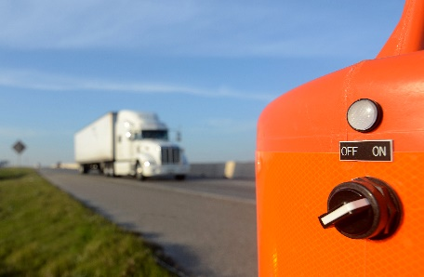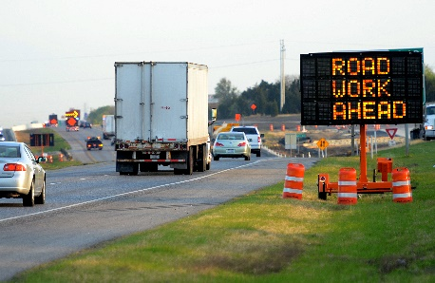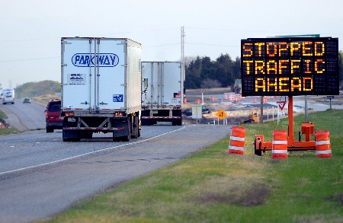
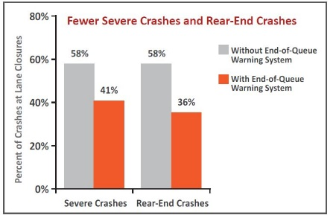

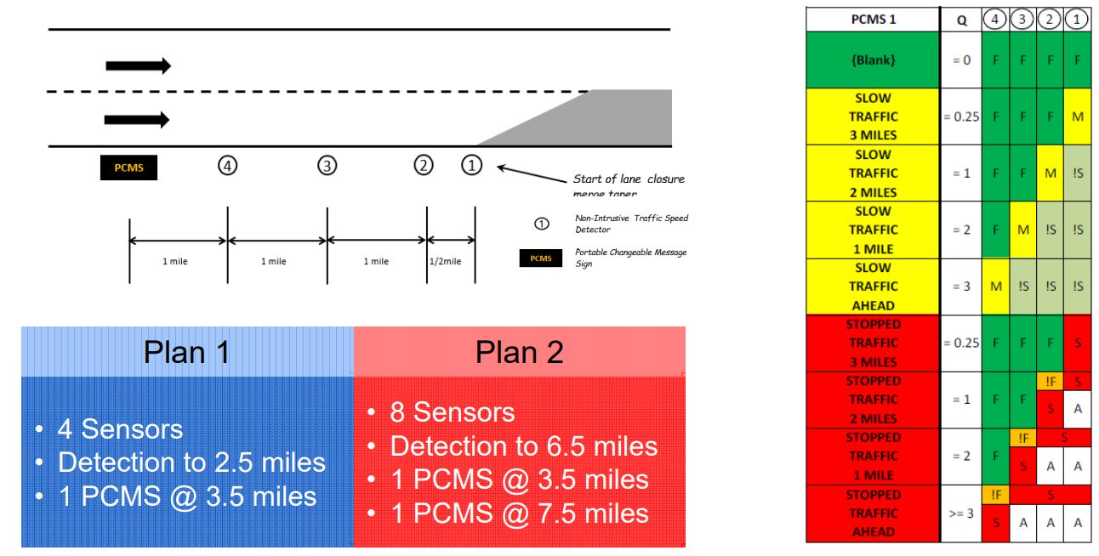
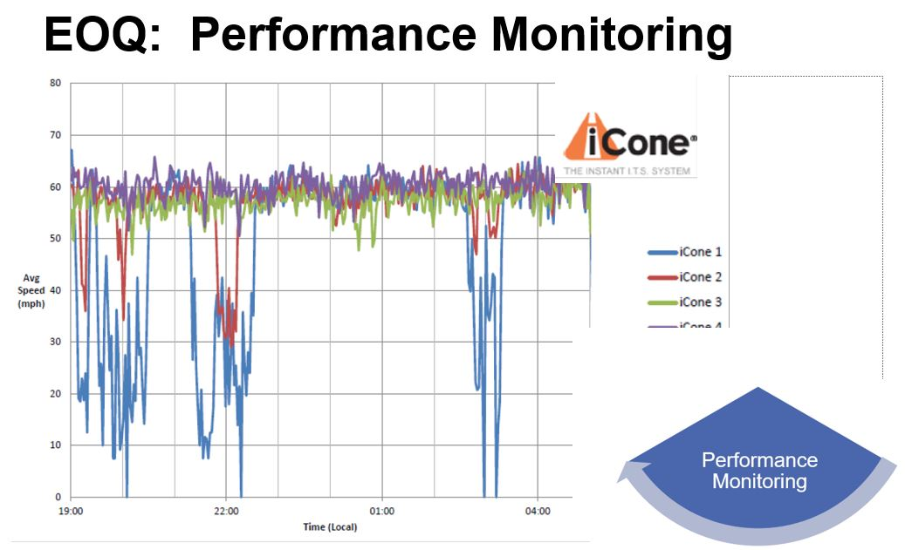
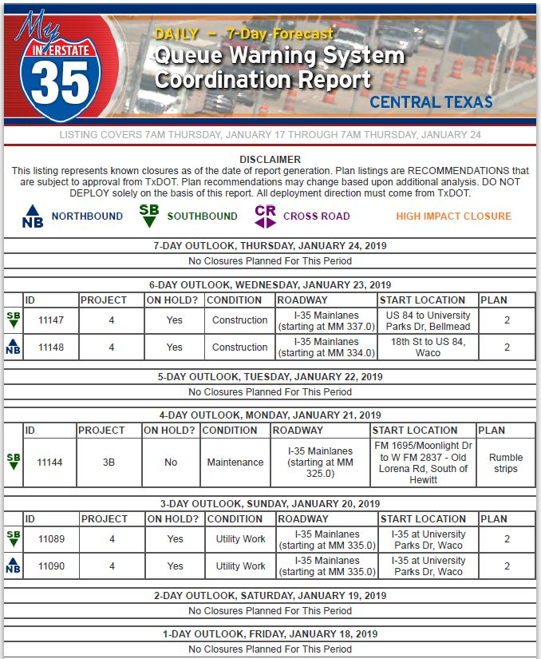
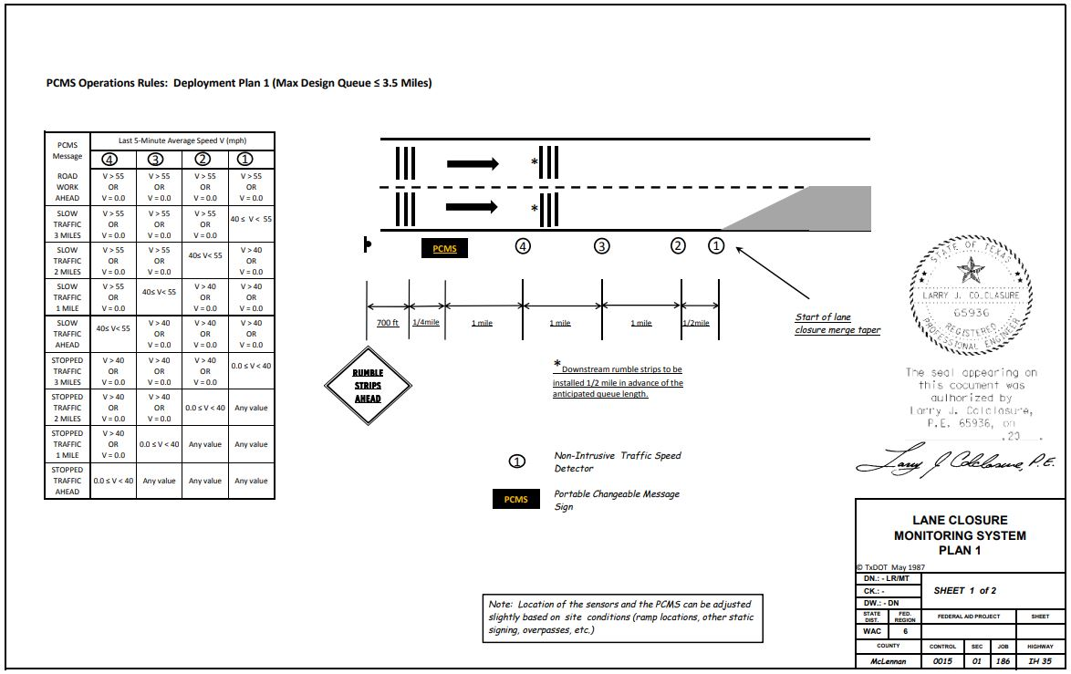

State of Development (40 points)

Innovations must be successfully deployed in at least one State DOT. The AII selection process will favor innovations that have advanced beyond the research stage, at least to the pilot deployment stage, and preferably into routine use.
9. How ready is this innovation for implementation in an operational environment? Please select from the following options. Please describe.
☐ Prototype is fully functional and yet to be piloted
☐ Prototype has been piloted successfully in an operational environment
☐ Technology has been deployed multiple times in an operational environment
☒ Technology is ready for full-scale implementation
Installations include research-based, as well as design-bid-build scenarios, deployed over 500 nights as well as statically for a 3.5 year project in the Waco District of TxDOT. Research is on-going to look at lessons learned for several implementations, including on I-35, a major interstate corridor. TxDOT specifications have been copied or referenced by at least 8 other states.
10. What additional development is necessary to enable implementation of the innovation for routine use?
No additional development is required. There is an on-going research project between TxDOT and Texas A&M Transportation Institute (TTI) to determine best practices for contracting, including guidance on whether state DOTs should consider self-deployment. Potential opportunities for advancement include the research of emerging detection technology, purchasing data streams (INRIX), and using connected vehicle data.
11. Are other organizations using, currently developing, or have they shown interest in this innovation or of similar technology?? ☒ Yes ☐ No
If so, please list organization names and contacts. Please identify the source of this information.
Organization | Name | Phone | Email
FHWA | Jawad Paracha | 202-366-4628 | Jawad.paracha@dot.gov
CALTRANS | Kevin Riley | 916-712-5881 | Kevin.riley@dot.ca.gov
Michigan DOT | Chris Brookes | 517-242-6486 | brookesc@michigan.gov
iCone Products | Ross Sheckler | 315-626-6800 | r.sheckler@iconeproducts.com
Street Smart Rental | Ryon Sanders | 651-802-5076 | rsanders@streetsmartrental.com

Potential Payoff (30 points)

Payoff is defined as the combination of broad applicability and significant benefit or advantage over baseline practice.
12. How does the innovation meet customer or stakeholder needs in your State DOT or other organizations that have used it?
Several studies have found that rear‐end crashes are often the predominant type of crash that occurs in work zones. Other studies have shown that rear‐end collisions usually increase in work zones more than any other type of crash. Many of these crashes occur when high‐speed traffic encounters the upstream end of a queue that is created by the work zone and are often quite severe. Customers (drivers) have a need to be kept safe and informed about construction work zone-related conditions. The end-of-queue warning system has shown up to a 55% reduction in the number of crashes that would have occurred without the technology being implemented, which increases the safety to the traveling public. In addition, drivers can use the information provided to alter their trip when necessary, avoiding delays. The usefulness of the system is particularly applicable to heavy truck traffic routes by reducing potential crashes between heavy vehicles and other roadway users.
13. Identify the top three benefit types your DOT has realized from using this innovation. Describe the type and scale of benefits of using this innovation over baseline practice. Provide additional information, if available, using quantitative metrics, to describe the benefits.
Benefit Types | Please describe:
Improved Safety | Research data related to past implementations show a 55% reduction in the number of crashes that would have occurred without the technology being implemented.
Cost Savings | The cost savings attributed to this system are related to calculated road-user-costs (RUCs). Delays from construction queue-related crashes can easily top $100,000 per day on major interstates, with secondary roads seeing RUCs in the tens of thousands of dollars per day. Using this technology can significantly reduce queue-related crashes, saving drivers the related RUCs.
Improved Operation Performance | Management of Traffic is a key component of a highway construction project’s success. As well as increasing safety, early warning systems allow drivers to make better-informed decisions, including whether to divert their trip onto alternate routes. In addition, the end-of-queue technology can be linked to social media, allowing for trips to be diverted away from construction zone traffic congestion before they even start.

Provide any additional description, if necessary:
Click or tap here to enter text.
14 How broadly might this innovation be deployed for other applications. in the transportation industry (including other disciplines of a DOT, other transportation modes, and private industry)?
The successful deployment of end-of-queue early warning systems acts as a proof-of-concept of base technology that can be easily adapted into many other well-engineered systems. At the core, the technology consists of changeable message signs, traffic detectors, and network communications devices. A few potential other applications include: emergency incident management, special event traffic management, or dynamic lane merge.

Market Readiness (20 points)

The AII selection process will favor innovations that can be adopted with a reasonable amount of effort and cost, commensurate with the payoff potential.
15. What specific actions would another organization need to take along each of the following dimensions to adopt this innovation?
Check boxes that apply | Dimensions | Please describe:
☒ | Gaining executive leadership support | Depending on a state DOT’s relationship and contracting structure with the industry, traffic control can sometimes rank low on the list for deployment, operations, and maintenance. Strong executive leadership support will ensure all industry partners give this technology the attention it requires.
☒ | Communicating benefits | Work zone-related crashes are a major concern for all State DOT’s and local municipalities. Communicating the benefits of this technology will show that the reduction in work-zone related crashes aligns with their goals of reducing serious-injury and fatal crashes.
☐ | Overcoming funding constraints | No funding constraints. Typical design-bid-build deployment averages 0.5% of total project construction cost.
☒ | Acquiring in-house capabilities | TxDOT and the Texas A&M Transportation Institute are currently researching best practices related to bidding these systems as part of design-bid-build, versus deploying, operating, and maintaining these systems in-house.
☐ | Addressing legal issues (if applicable) (e.g., liability and intellectual property) | Click or tap here to enter text.
☐ | Resolving conflicts with existing national/state regulations and standards | Click or tap here to enter text.
☒ | Other challenges | Educating law enforcement, potential conflict with “move over” laws.

16. Please provide details of cost, effort, and length of time expended to deploy the innovation in your organization.
Cost: The costs of utilizing queue warning systems depend on the length and duration of the project, as this dictates the amount of equipment needed and length of contracts required for cellular communication with those devices. Inclusion of additional smart work zone functionalities (i.e., travel time displays, incident detection and surveillance, etc.) would also increase costs of a system. On average, End-of-Queue system costs in Texas average only 0.5% percent of total project construction costs. As might be expected, the percentage tends to be larger for smaller contracts, but still tends to be less than 3% of total project costs. Expressed on a per-day basis, smart work zone systems typically cost a project between $300 and $350 per day.
Level of Effort: A State DOT, at the minimum, would be required to review and adapt existing specifications, review design guidelines, and determine contracting requirements and vendor availability. Each work zone or emergency deployment requires assessment prior to deployment. Field deployment effort is similar to deploying a standard portable changeable message sign and communication devices.
Time: The effort is minimal once equipment is procured. A typical setup can be deployed within a single day, with a following calibration and verification window ranging from a couple of days to a week, depending on responsiveness of vendors and contractors. New technology may make this a quicker deployment in the case of emergencies. (ie:. Tow the all-in-one trailer system, connect to network, auto-calibrate using purchased data feeds, start displaying message, and field verification all in a matter of hours.)
17. To what extent might implementation of this innovation require the involvement of third parties, including vendors, contractors, and consultants? If so, please describe. List the type of expertise required for implementation.
This technology is heavily reliant on vendors for equipment, including detection devices, signs, and network communication devices. However, all components for a basic system are readily available on the market. Implementation is typically through prime and sub-contracting of traffic control. There is an on-going research project between TxDOT and Texas A&M Transportation Institute (TTI) to determine best-practices for contracting, including guidance on whether state DOT’s should consider self-deployment.

